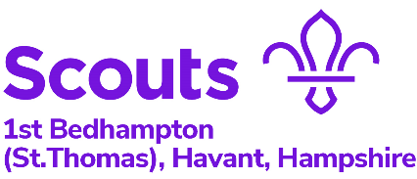

SCOUT CONSTITUTION
(How we run 1st Bedhampton Scout Troop).
Version Agreed 9th June 21
Extract From the National Website:
“Scouts aims to build and develop young people’s confidence, sense of adventure and outdoor skills, as well as encouraging them to explore their beliefs and attitudes and be creative. It offers them the independence to put these skills into practice at camps and even on international trips.
Scouts are encouraged to work together and take the lead on all sorts of projects, from community based work to planning games and activities for their meetings.”

1st Bedhampton Scouts will keep their Scout Promise and Law. It will keep to the National Scout Policy, Organisation and Rules.
1st Bedhampton Scouts and Explorers will be run separately and have separate constitutions. There may be joint activities to encourage linking.
The troop will run with a troop forum which will include all members (Scouts and Adults).
Changes to this constitution will need to be approved by all members of the Scout Troop at the troop forum. If a member is not there they can be contacted before or after, to check that they have no objections.
If somebody actively objects to a proposed change then their objections will first be discussed at the troop forum. If it still cannot be resolved, then an independent person will be asked to decide. That person needs to be agreed with both sides. It could be a Section Leader or Helper (if independent), a leader in another section or the Group Scout Leader or member of the Scout District.
The Troop forum and Patrol Leaders Council shall meet each half term, normally towards the start. The Patrol Leaders Council shall normally follow the Troop Forum and make decisions based on input from the Troop forum. The Troop Forum shall review success of past events and likely success of future events.
The Patrol Leaders Council shall be made up a representation of the leaders, Patrol Leaders and Senior Patrol Leaders. Assistant Patrol Leaders may also be invited. There shall be no more Adults present than young people.
The Patrol Leaders Council shall:
- Decide on any appointments for Patrol Leaders, Senior Patrol Leaders and Assistant Patrol Leaders.
- Review and make final decisions on the programme using feedback from the troop forum.
- Decide on standards of Uniform and Inspections.

