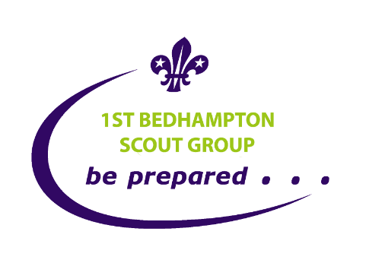
1st Bedhampton Scout Troop
CODE OF CONDUCT (Updated 7th Sep 22)
In order for all Scouts to get the most out of their time in Scouting & to enjoy it, we suggest that you take an active part in the life of the Troop & engage with the many activities & opportunities that Scouting can provide.
The Troop has a code of conduct for all its members. This is not a code or set of rules that have been imposed by the adult leaders, it has been created by involving our Scouts in the process . The code of conduct is also reviewed by the Troop membership and the Patrol Leaders Council to ensure that it is still relevant.
The following guidelines are therefore expected to be followed by our members (Scouts, Leaders and Helpers).
SCOUT PROMISE
On my honour,
I promise that I will do my best
to do my duty to God and to the Queen,
to help other people
and to keep the Scout Law.
There are variations of the promise including for those with no faith (see Bedhampton Scout Website)
- Scouts, Leaders and Helpers are expected to keep to our Promise and Law.
- All members have a right to be treated with respect and treated equally without prejudice or discrimination.
- Instructions by leaders or whoever is leading the activity need to be listened to. These may be for your safety.
- Swearing or Bad Language will not be tolerated.
- Visitors to the troop will be welcomed.
- Wear your uniform smartly & with pride.
- Come to what you can.
SCOUT LAW
- A Scout is to be trusted.
- A Scout is loyal.
- A Scout is friendly and considerate.
- A Scout belongs to the world-wide family of Scouts.
- A Scout has courage in all difficulties.
- A Scout makes good use of time and is careful of possessions and property.
- A Scout has self-respect and respect for others.

- If you promise to do something or attend something do your best to do so.
- Contribute your ideas. Let your Patrol Leader know of any ideas for activities.
- Learn what you can.
- There is no such thing as a “dumb question”? If you are thinking it others may be.
- Come to the Leaders about any concerns or problems
- Be intolerant of bullying & report it when you see it to an adult.
- Be honest & trustworthy particularly in games and competitions, you will gain respect for it.
- Set a good example to Cubs joining the Troop & new Scouts.
- Remember to smile & say Thank you, it does matter
- Mobile Phones are not required at Troop meetings. If you bring one, please put them on silent.
- Respect the fantastic headquarters you meet in & do not mess around in the toilets.
- On camp keep out of other people’s tents and gear.
- Patrol Leaders and Assistant Patrol Leaders should lead by example on the above.
- Have fun! That's what Scouting is all about
The Scout Group has a policy on discipline in the 1st Bedhampton Scout Group that would be used for serious or continued breaches of the above which involves. It is extremely rare that the formal part of this policy is used, and Parents/Guardians would be involved throughout.

PATROL POINTS
We have designed the Patrol Point System to reward good behaviour rather than correct bad, For example if someone has lost his scarf we still want them to turn up (and find their scarf for next week). We will award points as follows each week:
- 3 Points for turning up on time (before 7:10) and being in correct uniform.
- 3 Points for letting us know in advance that you will not be there/will be late (assuming uniform ok).
- 2 Points for turning up late (without notice) or having poor uniform (e.g. no scarf).
- 1 Point for turning up late (without notice) and having poor uniform (e.g. no scarf).
- If Patrols are for any reason different sizes (e.g. one has 6 and one has 5) then the smaller Patrol is awarded an extra 3 points as if they had an extra person.

