Welcome to
1st Bedhampton
Scout Troop

Name ……………………………………..

Where, When, How, What
Where do we meet?
We meet in St Nicholas’ Church Centre,
Belmont Grove, Bedhampton
If we are meeting anywhere else, you will be sent an email in advance
When do we meet?
Wednesday 7pm – 9pm
How much is it?
Subs are £15 a half term, these can be paid straight into the bank and can be paid termly.
What do we do?
We do lots of different things, some things are learning, and somethings are just for fun!
Rock climbing, knots, pioneering, camping, cooking, hikes, swimming, kayaking, creative things, mechanics skills, drama, helping others, team working, problem solving and lots and lots of other stuff ….

Leaders
Who else will you meet at Scouts?

Scout Leader Nigel Vosper
07979736459
nigeljvosper@sky.com
Other Leaders Nick Palmer
Caroline Setford
Rich Setford
Becks Vosper
Fraser Dart

Group Scout Leader Ian Barbery

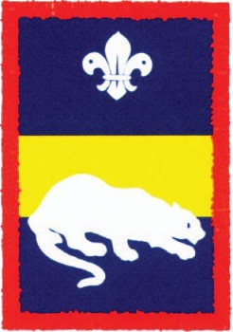
Panther Patrol
Patrol Leader

…………………………….………………………………….
Assistant Patrol Leader

………………………………………………….

…………………………………………………………..

…………………………………………………………..

…………………………………………………………..

……………………………………………………………
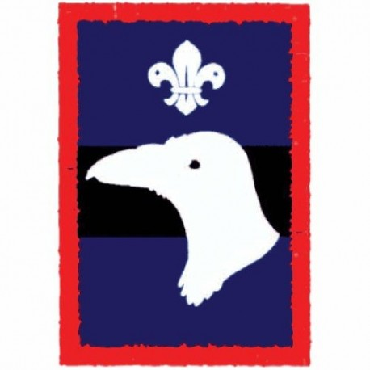
Raven Patrol
Patrol Leader

…………………………….………………………………….
Assistant Patrol Leader

………………………………………………….

…………………………………………………………..

…………………………………………………………..

…………………………………………………………..

……………………………………………………………
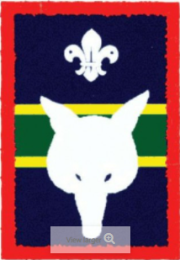
Fox Patrol
Patrol Leader

…………………………….………………………………….
Assistant Patrol Leader

………………………………………………….

…………………………………………………………..

…………………………………………………………..

…………………………………………………………..

……………………………………………………………
Badges
We work to earn different badges.
some are activity badges that go on our arm.
Some are challenge badges that go on our front,
Some are badges that we are given to show
Where we are from, how long we have been in scouts, any special roles we have or to mark special events.

Where to sew you badges on your uniform.
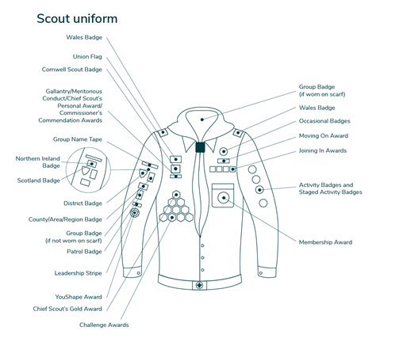

Where can I find out more?
There is a 1st Bedhampton Scout Group website
www.1stbedhampton.co.uk

Facebook Group
1st Bedhampton Scout Group

Online Scout Manager
You will be sent a link by email to access OSM, this shows our program and badges you have earnt. You can also sign up to different events here.

