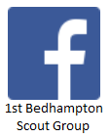
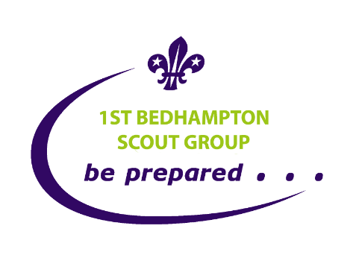

Additional Information on Scouts for Parents/Guardians:
This page contains additional information aimed at Parents/Guardians on 1st Bedhampton Scouts. Its not “secret information” and Scouts are encouraged to have a read.
Walking To & From Scouts Policy:
We understand that there is a big difference between a 14 year old walking a short distance home in summer, to a 10 year old walking home in the dark winter months several miles.
Therefore, we ask that Parents/Guardians are clear with their Children whether they can or cannot walk home. To assist with this we have created a consent form in OSM (Online Scout Manager – See Below) to inform us whether your child is allowed to travel to or from Scouts by themselves. By default we set this to permission to consent not given.
Please note that the Scout Association can take no accountability for travel from/ to meetings however our leaders and helpers will obviously stay with any youngster if there is a parent/guardian who is late in collection.
Online Scout Manager Access (OSM)
Shortly after you join you should receive an access link to online Scout Manager. This is a system we ask you to use to update records as they change. Common items are: Address, Telephone numbers, emails, medical or additional needs, permission to walk home from Scouts (see above).
It allows details to be entered for multiple Parents/Guardians and for Scouts themselves. Anything we send to Scouts we always send to the Parents Guardians as well.
The link can be resent at any time. Just ask. If you need us to update anything on your behalf just let us know.
As leaders We also record attendance which allows us to quickly update badges. We are also starting to use it to work out attendance at events along with some online “doodle polls”. We don’t yet use it to pay subs (see next section overpage)

Payment of Subs
Subs is currently set at £15 per half term/ £30 per term. The amount is set by our Group Executive Committee and more details on what it is spent on can be found in the Subs handout in our Group Welcome Pack.
Our preference is that payment is made by BACS transfer however if you wish to pay by Cash or Cheque feel free to do so.
You can find details on how to pay by the BACS transfer in the “Noticeboard” once you log onto OSM. P.S. I have just (23/02/22) made a change to OSM to make it more visible.
We are currently looking at some of the automatic payment features of OSM but haven’t started using them yet.
If anyone has any problems I can send them information. For security reasons I won’t put bank account details here.
Investiture and Uniform
A few weeks after joining Scouts and once they have settled in, we invite members to “be invested” as a full member of 1st Bedhampton Scout Troop and also the World Wide Fellowship of Scouting. Here are the details we hand out at the time. There is also a link to the uniform picture available here and variations of the Promise are available here.

Author Nigel Vosper. Version created 23 Feb 2022
Nigels Mob 07979736459 e: nigeljvosper@sky.com www.1stbedhampton.co.uk

